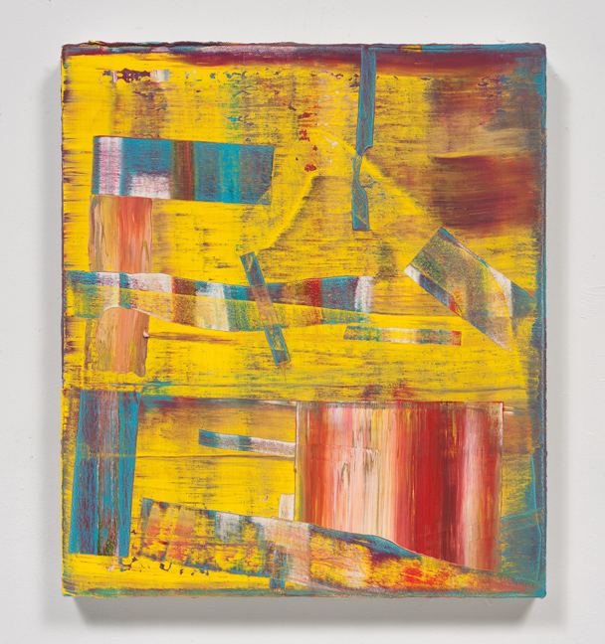 | One Foot on the Ground  July 2 – August 15, 2015  Opening Reception:  Thursday  July 2nd, 6:00-8:00pm  Left:  Tomory Dodge  Pyramids, 2012  Oil on canvas  16 x 14 inches  Gallery Hours:  Wednesday-Saturday, 11am-5pm  Tuesday by appointment only  Images are available upon request.

James Harris Gallery is pleased to present a group show of paintings and works on paper entitled, One Foot on the Ground, curated by artist Alexander Kroll. The show presents recent work by sixAmerican painters: Tomory Dodge, Joanne Greenbaum, Jane Hugentober, Tom Knechtel, Erin Morrison, and Craig Taylor. One Foot on the Ground is not a themed exhibition. This is a taste driven enterprise, and as the history of painting tells us, the nature of taste is central to how the language of abstraction is constructed, conceived, perceived, disseminated, deconstructed, parsed, purchased, categorized, collected and loved.

For these artists, abstraction is the jumping off point. Their work explores the threshold that exists between figuration and abstraction, and how these boundaries are pushed in order to discover what lies just beyond the recognizable, the in-between state where a picture pushes against the edge of physicality and challenges the observer’s perceptions. It is in this moment of falling off balance, of allowing for chaos to ensue that these artists discover the associative domains beyond the visual arts through performance, poetry, fairytales, psychology, archeology, diagrams, and topography - and create their own language of abstraction through suspension and dislocation of form. By bringing together works by both established and emerging artists, this exhibition creates a conversation of diverse visual languages of a moment.

For this exhibition, painting is the primary means of creation forthese signature abstract languages, howevermany of these artists have incorporated mixed media into their practice. For Joanne Greenbaum, Tom Knechtel, and Craig Taylor drawing has become an unavoidable conduit to their gestural mark. For Taylor, this finds expression in layered works on paper, utilizing paint, collage, graphite and colored pencil to generate forms and spaces that suggest but continually defy identification and defer specific meanings. Through cartoon-esque figuration, Taylor creates polymorphous and joyously perverse works on paper. We see echoes of Guston and the New York School in Taylor’s concern for the tactility of paint and the possibility that abstraction can serve as a gateway to something at once comic, Romantic and above all - deeply human.

Knechteloften works from drawing into painting, finding synergy between the two. His work is spurred by his own experience, taste and connoisseurship. In his work, thebody is cast in both the role of subject and as vehicle, giving the viewer access to the intimate, erotic dance that occurs between painter and painting.Greenbaum works in varied media as sculptor, painter and mark maker, but has only recently merged her personal practice of drawingwith painting as part of her evolution towards the unfiltered abstract gesture. Greenbaum’spainterly, still-life spacesare enlivened with her sculptural sensibility. Unfettered by sentimentality, her tactile desires inform her choices in material in this artistic dance between painting sculpture and drawing. For both of these artists, this intersection of media suggests the relationship between the public life of the artist and the private life in the studio.In this sense, their intimate discoveries of the small gesture of the hand are monumentalized through the expressive nature of painting and brought to a wider audience.

Emerging artists Jane Hugentober and Erin Morrison renegotiate the confines of a painterly space through their experimental approaches tothe support structures of their work. Morrison creates her own “blank canvas” through her plaster reliefs of palm leaves, an iconic symbol of Los Angeles topography. The tactile surfaces of her paintings are instilled with cultural implications that both inform and disrupt the painted marks. Jane Hungentoberabandons the support structure all together, stretching and draping her materials and allowing her pieces to exist in an experiential environment. This “play space” of her work is an embodiment of artistic experience, a layered narrative of the physical performance of creation Hugentober refers to as “play processes” that relate to her own complex sense of identity and true self.

Tomory Dodge makes lush, juicy paintings that move back and forth between pure abstraction and allusions to representational space. Earlier in his career, Dodgemade explicitly photographic paintings.The mediated image no longer operates as the subject matter of his work. Without the need for photographic referent, the transportive quality remains through allusions to cosmic spaces. The many layers of marks of the resultingintentional chaoshave a powerful effect, seductive in their physicality.

Collectively, the varied approaches of these artists bring us back to the emblematic modernist archetype of a visual flaneur…wandering through art history and contemporary culture - high and low - picking and choosing visual languages that suit their fancy and needs at any given moment.In light of a modernist history of abstraction, Joanne Greenbaum in interested in reinterpreting the stereotypes of modernism, the “drips and smears and scribbles” that have been a part of art historical language over the past century. For many, the source of their abstraction is performative. For Dodge, the work becomes about “the representation of gesture.”Tom Knechtel likens his practice to the theatre when he describes it as “based on an interaction between the desire to suspend disbelief, the need to communicate and how impermanent that transaction is.” The works in this exhibition become a stage, a theatrical space for the artist to act upon and for the viewer to both experience and contemplate, perhaps with one foot on the ground.

