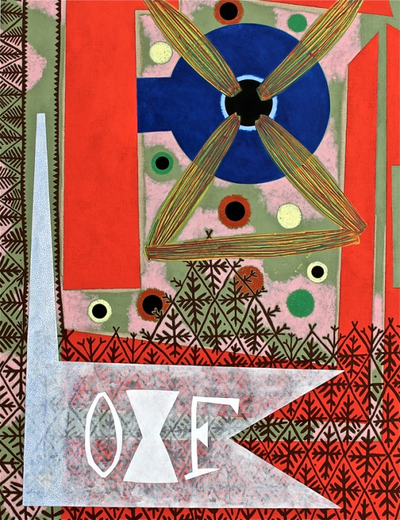 | Roy Dowell: New Work  October 17 to November 27, 2013  Opening Reception:  Thursday, October 17, 6 – 8pm  Gallery Hours are:  Wed. - Sat. 11:00am - 5:00pm  Tuesday by appointment  Additional images are available upon request  Left: Untitled #1027, 2013 acrylic on linen, 52 x 40 inches

James Harris Gallery is pleased to present our first solo exhibition by Roy Dowell. The exhibition will include painting, sculpture and collage; key elements of the artist's practice. For over 30 years, Roy Dowell has been making pictures, primarily collages and paintings that continue his signature exploration of his interest in modernism. His two dimensional works combine illusionistic space through layering of images, geometric and biomorphic shapes along with patterning. His works are undeniably abstract but referential material often appears in his compositions to wrestle with pictorial space where everything happens inside painting itself. His two dimensional works address the space within a flat surface and requires the viewer to participate in deciphering the fore, middle and far ground within it. His compositions explore pictorial structure. Only recently has he turned to sculpture to explore these ideas. All of his work shows us how he translates familiar elements and their many associations into abstract form.

In both Dowell’s paintings and works on paper, he investigates the language of abstraction, incorporating a wide spectrum of multicultural and design sources. The core of his artistic practice has its roots in modernism and mid-century abstraction incorporating elements of advertising and decoration. In the painting “Untitled #1027, the pictorial structure is densely layered. Through the artist use of color and form, he is able to create movement and energy where shapes play off one another. Bold geometric areas of red sit on top of a mottled green and pink ground. In the bottom third of the painting and the border of the left side, the artist has intricately painted an organic leaf and diamond like pattern that creates a visual screen to the colors below. Complicating the pictorial space again is an opaque area of white that sits on top of these layers activating the surface. The final tussle of spatial play between the shapes and patterns come in the forms of two or perhaps three letter of the alphabet in sold white paint.

Dowell’s collages operate in the same manner of his paintings but on a more intimate scale. Emphasis is still place on color and form to stimulate the viewer to perceive the fractured layers of the picture plan through the aesthetics of sensory perception. Seen together the collages and the paintings demonstrate the artist’s desire to make discrete works where everything happens inside the boundaries of the constructed object.

The sculptures are modestly scaled works whose forms are inspired by objects found during his travels. They reference the vernacular of ceremonial objects of different cultures, from Oceanic to African to Latin American. The sculptures made from paper and cardboard and decorated with acrylic paint either hang from the wall or sit on pedestals. The scale and shape have a distinct reference the body. Dowell, like the early modernists artists, sees the importance of these non-Western influences as a way to confront the conventions of contemporary sculpture.

Roy Dowell lives and works in Los Angeles. His work was recently featured in the 2012 “Made in L.A.” biennial at the Hammer Museum. His work is in the permanent collections of LACMA, MOCA Los Angeles, The Hammer Museum, SFMOMA, MCA San Diego, the Jumex Collection, the Eli Broad Collection, and many other significant institutional and private collections.

